Image | 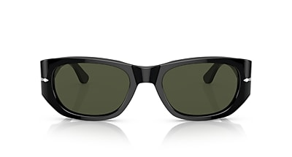
Brand | OLIVER PEOPLES
Model Name | PO3307S
Price | RS 3359
PRODUCT DETAILS

